BlockChain(LetsUpgrade): Project->Student Report Card-

### Submited By= Tushar K Gaikawad

**Note= This pdf file contain the

1. Source Code (.sol ) format
2. Debug—include- hash,to,from etc
3. Injected Ropsten networks
4. ScreenShot of various Transaction

//////////////////////////////////////////////////////////////////////////////////////////////////////////////////////////////

pragma solidity ^0.4.22 < 0.6.12;

contract Report_Card{

string public name;

uint public rollno;

uint public batch;

string public status;

uint sub1;

uint sub2;

uint sub3;

uint sub4;

constructor(string newname,uint newrollno,uint newbatch,uint marks1,uint marks2,uint marks3,uint marks4)public{

name = newname;

rollno = newrollno;

batch = newbatch;

sub1 = marks1;

sub2 = marks2;

sub3 = marks3;

sub4 = marks4;

uint result = sub1 + sub2 + sub3 + sub4;

if(result > 160){

status = "Pass";

} else {

status = "Fail";

}

}

function getStudentDetails()public view returns(string,uint,uint,string){

return(name,rollno,batch,status);

}

}

|  |  |
| --- | --- |
| transaction hash | 0x3ef3d4d27f896903832017f702b22dd4019ec4c84d20df0d593872a3294c671c |
| from | 0x8500E2F3f090166c9c976698732a32b5cAf10A4B |
| to | Report_Card.getStudentDetails() 0xeAb00619Ef72e69d921E3C2d5Ec90dCe134Fb6F8 |
| transaction cost | 29306 gas (Cost only applies when called by a contract) |
| execution cost | 8034 gas (Cost only applies when called by a contract) |
| hash | 0x3ef3d4d27f896903832017f702b22dd4019ec4c84d20df0d593872a3294c671c |
| input | 0xbc6...58659 |
| decoded input | {} |
| decoded output | { "0": "string: Ravi Shankar", "1": "uint256: 32", "2": "uint256: 1", "3": "string: Pass" } |
| logs | [] |

**>**

# Conforming The Trasaction To Be Deploy on ***Ropsten Testnet Network***

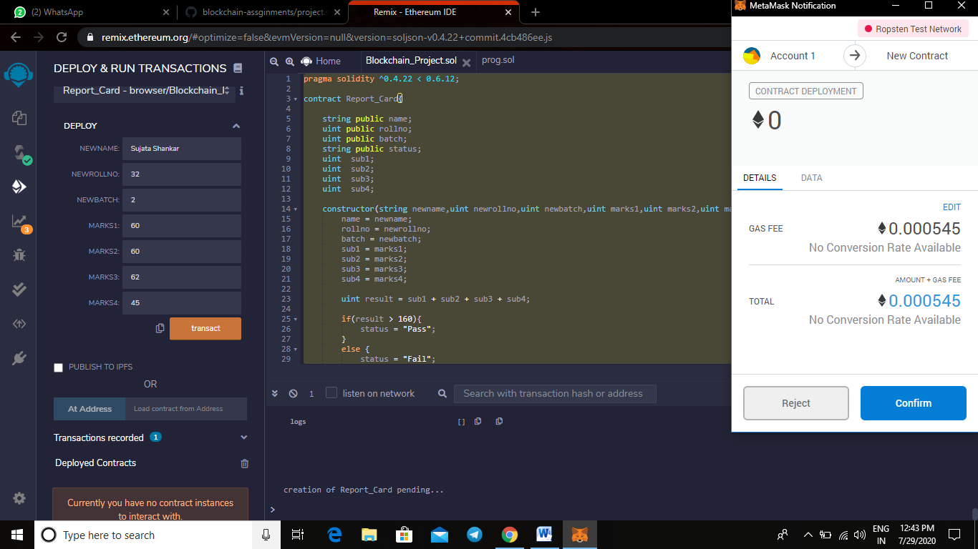

# Transaction Is Pending/Sucessful

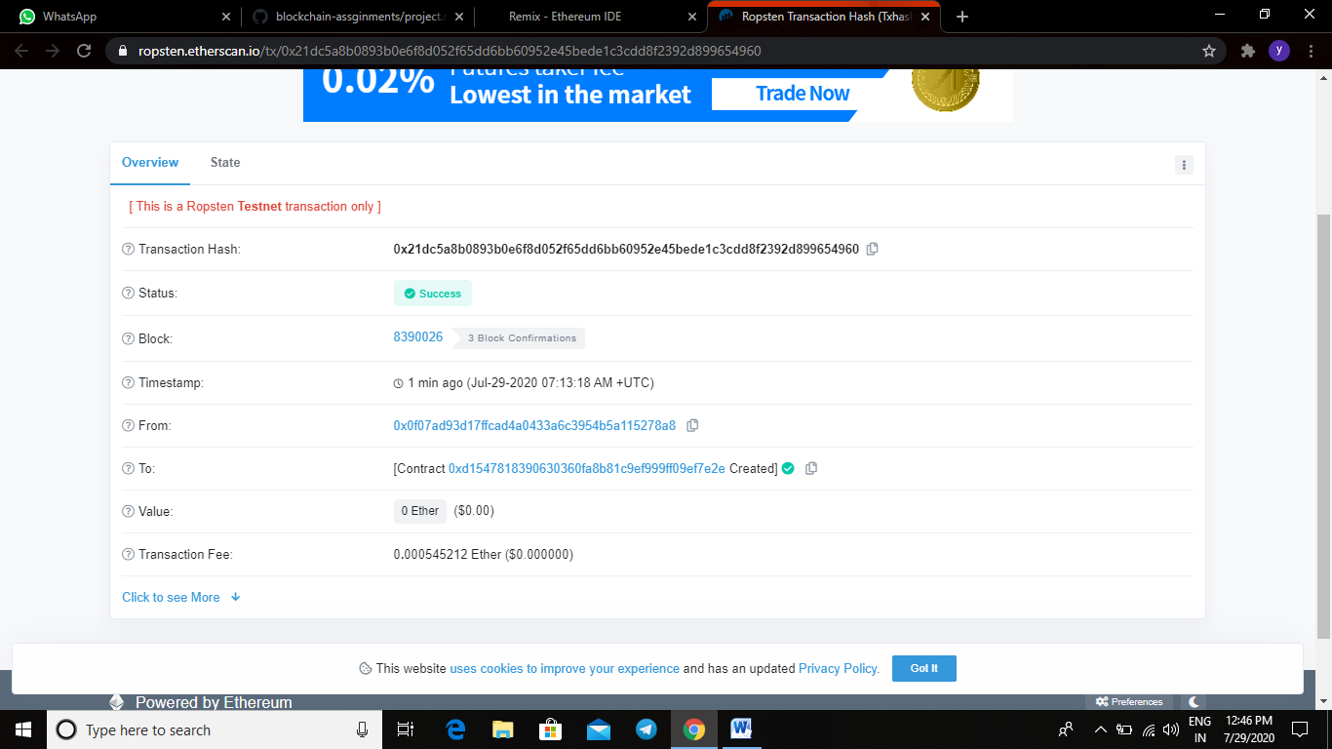

# State

